*General information for running events: ____________________________________________page 1*

*Running an event on campus: ____________________________________________________page 6*

*Running an event off campus: ____________________________________________________page 8*

General information for running events

Events are a great way to grow and celebrate your club or society as well as learn new skills. This guide contains all the info you need to know about running fun, successful, and safe events on or off campus.

1. **LTSU clubs and societies event booking form**

This form must be completed by ALL clubs before ALL events and submitted to LTSU. It also includes a handy checklist of steps to be done before the event and relevant timelines.

The form is available at [latrobesu.org.au/Common/ContentWM.aspx?CID=73#Events](http://latrobesu.org.au/Common/ContentWM.aspx?CID=73)

1. **Inclusivity**

All events run by clubs and societies should be inclusive to all students. This means that every single person should feel comfortable attending no matter their gender, sexual orientation, religion, cultural background, or any other factor. Make sure you consider this when planning and advertising events. Consider days of religious observance, what food options you are providing, and how you are advertising an event.

**Choosing a date**

Check that you are not scheduling your event for religious holidays or observances (see the La Trobe Equality and Diversity Calendar), or at the same time as any other event (see the LTSU events guide on the LTSU homepage)

**Catering for all**

Your club should consider cultural and dietary requirements when making catering arrangements. Always provide options that everyone can eat, including Halal, Kosher, vegetarian or vegan and gluten free options.

**Advertising**

When advertising an event, think about what implicit messages you are conveying, and make sure your event feels open and welcoming to all students. This means making sure your message isn’t sexist, racist, or exclusive in some other way, that prices and catering options are clear, and that it’s clear how students can get involved (contact details, time and date, clear instructions on location, etc.)

1. **Manual Handling**

Many club events involve packing and unpacking equipment such as tables, BBQs, boxes of brochures, etc. Please be aware of safe manual handling when taking part in these activities so that you don’t injure yourself. Please make sure you lift things safely and ask for help lifting things if you need it.

* Make sure you keep your back straight and bend your knees when picking things up (rather than bending at the waist and hurting your back)
* Try to avoid twisting when you’re carrying heavy items such as boxes of brochures etc.
* Where possible make more trips with a lighter load rather than overloading yourself with weight
* Use trolleys etc to help when transporting a heavy load
* Keep heavy loads close to your body when carrying (be particularly careful when leaning into somewhere like a car boot, it’s easy to hurt your back in that position)

1. **Risk, insurance and public liability**

It’s not a bad idea to be aware of risk no matter what the size of your event, but as soon as you have an on campus event involving alcohol or more than 30 people, or any event off campus, you must let LTSU know about your event AND complete the Risk Management Assessment Form. This is available at [ltsu.wufoo.eu/forms/risk-assessment-for-club-events/](https://ltsu.wufoo.eu/forms/risk-assessment-for-club-events/). Doing this means that you are as covered as possible by LTSU’s insurance policy.

Insurance (e.g. public liability) is dealt with on a case-by-case basis, so unfortunately we can’t give you a blanket rule to follow in order to ensure your events are covered by the university’s policy. The best we can do is say that you would **not** be covered if you were running an event that is outside of your club’s stated goals, if you were running an event outside the university or venue’s regular hours, or if you had not taken reasonable precautions to keep your event safe and under control.

For off-campus events, La Trobe University offers some insurance coverage for Public and Products liability, limited cover for student personal accidents, and no coverage for motor vehicles, but this insurance is only provided if the event is organised with the knowledge and consent of LTSU (acting on behalf of the university’s Risk Management department).

If your event is held at an external venue discuss insurance requirements when you hire the space.

Quick guide to forms and actions needed for all LTSU club and society events:

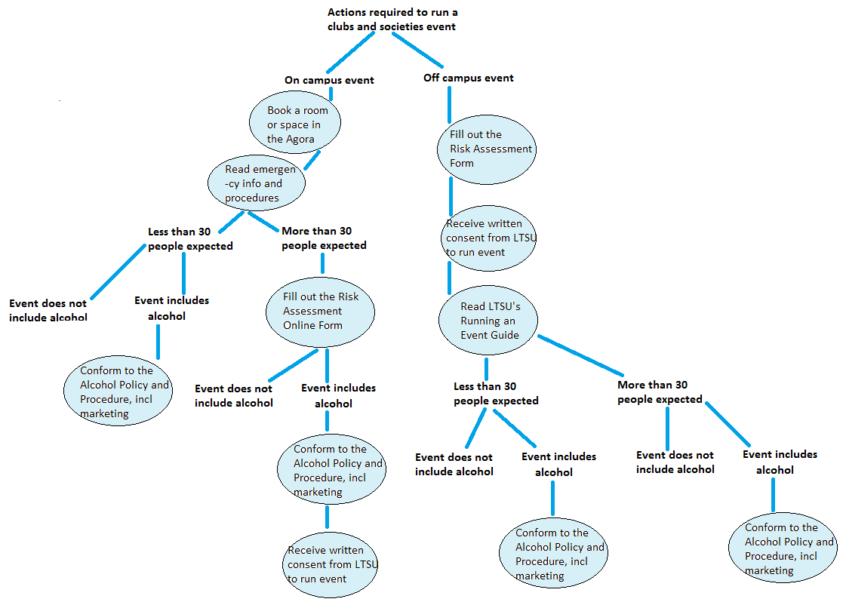

**Form locations:**

LTSU’s Agora Booking Form - [latrobesu.org.au/Common/ContentWM.aspx?CID=88#Events](http://latrobesu.org.au/Common/ContentWM.aspx?CID=88#Events)

La Trobe Room Bookings - [www.latrobe.edu.au/timetable/room_bookings.php](http://www.latrobe.edu.au/timetable/room_bookings.php)

Emergency Info and Procedures - [www.latrobe.edu.au/emergency](http://www.latrobe.edu.au/emergency)

LTSU’s Risk Assessment Form - [ltsu.wufoo.eu/forms/risk-assessment-for-club-events/](https://ltsu.wufoo.eu/forms/risk-assessment-for-club-events/)

Alcohol Policy and Procedure - [www.latrobe.edu.au/policy/documents/alcohol-and-drugs-procedure.pdf](http://www.latrobe.edu.au/policy/documents/alcohol-and-drugs-procedure.pdf)

LTSU’s Running an Event Guide: [latrobesu.org.au/Common/ContentWM.aspx?CID=73#Events](http://latrobesu.org.au/Common/ContentWM.aspx?CID=73)

1. **Serving food**

LTSU offers free Food Safety training a number of times a year. If your club serves food you should make sure at least one member of your executive has attended one of these sessions. You can also do a free online course at [www.dofoodsafely.health.vic.gov.au](http://www.dofoodsafely.health.vic.gov.au)

Food safety is really important and affects the ability of your club to run future events. Your event may be randomly visited by the local council so make sure you do the following at all times:

*Cold storage*

* Cold food must be 5°C or colder.
* Frozen food must be frozen hard.
* Check the temperature of fridges and cold storage areas regularly.
* Thaw food in your fridge, away from, and below, cooked or ready to eat food.

*Preparation*

* Keep food during refrigerator at all times and limit time in the temperature danger zone (between 5 and 60°C)
* If food is kept between 5 and 60°C for more than 4 hours throw it out.

*Cross-contamination*

* Always use plastic gloves when handling food
* Cross-contamination occurs when harmful bacteria or allergens spread to food from other food, surfaces, hands or equipment. This can lead to food-poisoning, to ensure cross-contamination does not occur, make sure you;
  + Keep raw food separate from cooked or ready-to-eat food.
  + Use separate utensils and cutting boards when preparing raw and cooked or ready-to-eat food.

*Cooking food*

* Use a thermometer to make sure foods are thoroughly cooked and the middle reaches 75°C.
* Hot food must be kept at 60°C or hotter.
* Check that only clear juices run from thoroughly cooked minced meat, poultry, chicken or rolled roasts.

*Cooling food*

* High-risk food must cool from 60°C to 21°C in the first 2 hours, and then to 5°C or lower in the next 4 hours.
* Once food has cooled to 21°C put it in the refrigerator or freezer.
* Large portions of food take longer to cool. Divide large portions into smaller batches before cooling.

*Cleaning*

* Use clean, sanitised and dry cutting boards, equipment and utensils.
* Clean and rinse wiping cloths after each use, and change frequently.
* Wash hands thoroughly and regularly.
* Return BBQ to a hygienic state

*Serving*

* Ensure all volunteers have washed hands, have gloves on and have hair tied back before food handling commences.
* Allocate volunteers to either cooking or serving. Advise those cooking meat to do spot checks on meat temperature with the meat thermometer.
* Don’t share tongs: use one set of tongs for raw meat and one for cooked meat.
* Cooked meats should be brought to the table and served from there using gloves and tongs.
* Make sure no one reaches over the hot cooking area to serve

For more information call 1300 364 352

www.health.vic.gov.au/foodsafety

(Guidelines published by the Victorian Government, Department of Health)

1. **Alcohol and other drugs**

You should always work to create a positive club culture that looks after its members and makes sure everyone feels safe, where there are people looking out for each other, and where no one is taking advantage of someone’s impaired judgement because of alcohol.

If you are serving alcohol, you must read over La Trobe’s [Alcohol and Other Drugs Policy](http://www.latrobe.edu.au/policy/documents/alcohol-other-drug-policy.pdf) and [Alcohol and Other Drugs Procedure](http://www.latrobe.edu.au/policy/documents/alcohol-other-drug-procedure.pdf) ([www.latrobe.edu.au/policy/documents/alcohol-and-drugs-procedure.pdf](http://www.latrobe.edu.au/policy/documents/alcohol-and-drugs-procedure.pdf))

LTSU also provides free Responsible Service of Alcohol (RSA) training to club executives.

**Advertising an event with alcohol**

Marketing, promotion or sponsorship of events which involve alcohol must only depict the responsible and moderate consumption of alcohol beverages, and accordingly:

(a) must notencourage excessive consumption, misuse or abuse of alcohol or promote offensive behaviour;

(b) must not encourage under-age drinking;

(c) must not promote events that encourage the rapid consumption of alcohol;

(d) must not identify access to free or cheap alcohol;

(e) must not depict the consumption or presence of alcohol as causing or positively contributing to personal, academic, business, social, sexual, sporting, or other successes and activities;

(f) must not suggest that the consumption of alcohol offers any therapeutic benefit or is a necessary aid to relaxation; and

(g) must not suggest that the consumption or presence of alcohol may create or contribute to a beneficial change in mood or environment.

If your event is in a licensed venue, e.g. the Eagle Bar, or at a venue off campus, you don’t need to police the consumption of alcohol as those serving will have a Responsible Service of Alcohol certificate and training. You do still need to make sure that your advertising complies with the policy though.

Every activity where alcohol is served must have at least one person nominated as the event coordinator who will be responsible for the planning and management of the event, including minimising risk from alcohol.

Living Well @ La Trobe has more information about [alcohol use and support](http://www.latrobe.edu.au/students/living-well/drugs) on campus. Go to [latrobe.edu.au/students/wellbeing/health-and-wellbeing/living-well/drugs](http://www.latrobe.edu.au/students/wellbeing/health-and-wellbeing/living-well/drugs) to read more.

# *RUNNING AN EVENT ON CAMPUS*

1. **Using the BBQ**

There is a barbecue which is free for all LTSU-affiliated clubs to use, you can book it through reception on 9479 2314. A $20 and student card deposit is required. Please read the LTSU barbecue process for details on transport of meat, and running a safe barbecue. The BBQ Safety fact sheet is available at [www.latrobesu.org.au/clubsresources](http://www.latrobesu.org.au/clubsresources)

The BBQ MUST be returned in a clean and hygienic condition or your deposit will be forfeited.

1. **Electricity in the Agora**

You must supply your own power leads which should have been tested and tagged within the preceding 12 months. Power outlets surrounding the trees in the Agora are not undercover and are only to be used in fine weather. All extension leads must be positioned to avoid foot traffic, and covered with lead cables available from LTSU. If you require a step ladder to reach an outlet in the Agora, ask the library reception staff.

1. **Sound equipment and noise**

Although clubs are permitted to play music from Agora stalls it must be at a volume that is audible from the area immediately surrounding the stall. LTSU and University staff (e.g. OH&S staff) are permitted to ask clubs and groups to reduce the volume of their music and clubs are expected to comply with this request. All sound must be switched off by **2pm** in the Agora.

If you would like to arrange sound equipment, you can do so through LTSU. Book ahead in advance so you don’t miss out.

1. **Booking space on campus**

Room bookings - If you’re running an on-campus event like a film screening or debate, contact [Room Bookings](http://www.latrobe.edu.au/timetable/room_booking_form.php) ([latrobe.edu.au/timetable/room_bookings.php](http://www.latrobe.edu.au/timetable/room_bookings.php)) to request the use of a room. Not all rooms are available for student use, as some have very specific teaching set-ups. There may be additional costs for using a room outside of normal university hours.

Agora space - is managed by the LTSU reception, you can call 9479 2314 or visit LTSU reception (Upper West Agora) to book a space. You must fill out the [Agora Booking Form](http://latrobesu.org.au/Common/ContentWM.aspx?CID=88#Events and bookings" ) ([latrobesu.org.au/Common/ContentWM.aspx?CID=88#Events](http://latrobesu.org.au/Common/ContentWM.aspx?CID=88#Events)) to book a space.

[Eagle Bar](http://www.latrobe.edu.au/book-la-trobe/functions-and-venues/event-venues/the-eagle) - If you want to use the Eagle Bar you will need to contact La Trobe Functions on 9479 3612 (Jayde Wood) or on [latrobefunctions@chartwellsedu.com.au](mailto:latrobefunctions@chartwellsedu.com.au) to organise that. If you want to use the bar outside of its regular operating hours, be aware that you may need to pay extra costs to cover their staffing and security needs. Regular hours are daytime Monday to Friday, usually until approximately 7pm, other than Thursday nights which are their late bar night. You can book different sections of the bar, but there will be other people in the bar as well. If you want to book the entire bar, you will need to arrange that for outside of their normal operating hours.

|  |  |  |
| --- | --- | --- |
| **Eagle Bar -Section available for reservation** | **Can seat this many people** | **Other details** |
| North Podium | 60 | Open fireplace during winter |
| South Podium | 15 | Open fireplace during winter |
| The Pit | 20 |  |
| Beer Garden | 40-50 | Marquees available |
| Rest of Eagle Bar |  | Staff are happy to put together tables of any size to suit the needs of your function in the rest of the Eagle Bar |

1. **Campus security**

For any events on campus with over 100 people you will need to advise campus security on 9479 2012. If you are holding your event in the Union Building rooms or Eagle bar they will arrange extra security should you need it. For events not in the Union buildings that require extra security staff you will need to email Anna King (Security manager) at [anna.king@latrobe.edu.au](mailto:anna.king@latrobe.edu.au) Let Anna know the time of your function and how many people you are expecting, she will advise how many additional security staff you will need and any costs involved.

1. **Campus Parking**

For any functions over 100 people during the day you will need to advise Martin Smith on 9479 2514 or [martin.smith@latrobe.edu.au](mailto:martin.smith@latrobe.edu.au). Martin will be able to organise and advise on parking availability to ensure your event runs smoothly. Parking after 5pm is free however function patrons cannot at any time park in yellow, blue or green bays.

1. **Emergency response information and procedures**

View and familiarise yourself with La Trobe’s Emergency Response Information and Procedures before your event ([www.latrobe.edu.au/emergency](http://www.latrobe.edu.au/emergency))

# Running events off campus

1. **Choosing a venue**

Where the university’s insurance doesn’t provide coverage (see section above), you will need to know that your club members are covered by external companies’ public liability insurance. For example, rather than hiring a mini-bus and driving it, you should organise the activity through a company which can also provide public liability insurance for you day’s activities.

When choosing a venue, make sure that it is accessible for those with different mobility needs (e.g. wheelchair).

1. **Alcohol off campus**

Despite the event occurring off-campus, for all on-campus and direct-to-student advertising (e.g. online through your club’s social media sites), you must still abide by the marketing of alcohol policy as detailed above. You should also consider what safe transport options there are for students leaving the venue, such as availability of public transport or taxis. And you should always encourage a positive club culture that looks after its members and makes sure everyone has a night where they feel safe, where there are people looking out for each other, and where no one is taking advantage of someone’s impaired judgement because of alcohol.

For assistance or further information contact the LTSU Clubs and Societies Officer on

[clubsofficer@latrobe.edu.au](mailto:clubsofficer@latrobe.edu.au), 9479 3752, 9479 2314